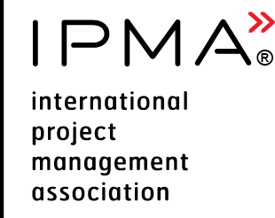 | CC Case Study  for Levels A, B, C Candidate | 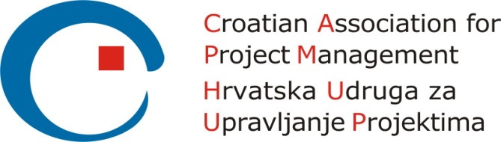
Please consider the environment before printing this document

Version control
Version and date of CVMB approval | Date | Valid until
Version 1.0 | 28.09.2019 | N/A

 | CC Case Study  for Levels A, B, C Candidate | Reserved for  CB logo

Candidate Name |  |  | Insert link to your CV
Level Applied for (check one) | IPMA CC Level A | IPMA CC  Level B |  | IPMA CC  Level C
Assignment Title / Name

General Information
Candidates for levels A and B must provide at least 2 case studies, candidates for level C – at least 1 case study. Your case study shall be no more than 25 pages using a font size of 11 points. You may include an additional 15 pages for appendices. Material in the appendices must be cross-referenced to the body of the case study text.

Background
Provide a detailed description (maximum 3 pages including graphics) of your background. Use the table for the description.
Characteristics | Description
Description of organisation
Type and scope
Assignment objectives and resources
Key stakeholders
Your role(s) and responsibilities(s)
Distinctive elements of your consulting/coaching assignment
Delivery of consultancy and coaching services
Results and client’s satisfaction
Lessons learned
Other (add what you consider assessors should know)

Challenges of the assignment
Please provide an overview of the challenges throughout the period of the assignment. Your report shall address your experience as follows:
- your management and leadership challenges with respect to others;
- how these were acted upon and the results achieved; and
- a reflection on the results and lessons learnt.
You can use the STAR approach (Situation, Task, Action, Result) to structure each competence element in your case study.
A total of 80% of ICB4CCT competence elements for the applied role must be referred to throughout the case study.

Case Study
3. Common Competences
3.1 Professional networking
3.2 Client insight
3.3 Ethical, legal and professional standards
3.4 Communication
3.5 Uncertainty management
3.6 Self-improvement
3.7 Change support
3.8 Expectation management
3.9 Outcomes
4. Specific competences for consulting
4.1 Assignment design
4.2 Guidance
4.3 Consultancy methods
4.4 Benefits evaluation
4.5 Innovation
5. Specific competences for coaching
5.1 Coaching environment
5.2 Facilitation
5.3 Coaching models and interventions
5.4 Insights and learning
5.5 Coaching evaluation

