 | IPMA ICR HB  Complaint Form | 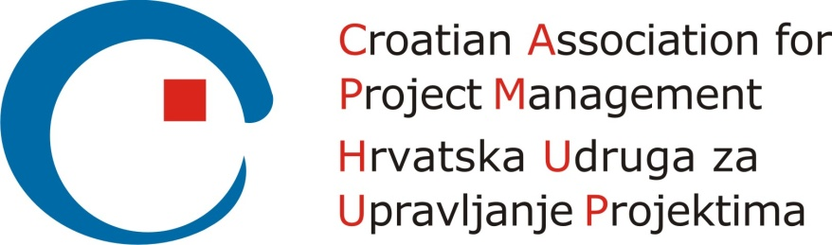

Please consider the environment before printing this document
Version control
Version and date of CVMB approval | Date | Valid until
Version 1.0 | 10.01.2017 | N/A

Configuration control
Date | Version | Section | Change
05.11.2016 | 0.1 | all | - Initial draft
12.12.2016 | 0.2 | all | - Minor changes in wording and style according to Document Design Guidelines
10.01.2017 | 1.0 | all | - Changes made and agreed by CVMB  (Role of Complaintant, the CB’s outcome)  - Endorsed by CVMB for CB use and modification

Name
Role

Nature of the complaint

Are there any supporting documents to support your complaint?

Date of complaint (YYYY-MM-DD): __________________________
Signature: _____________________________________________

For the Certification Body office’s use only:
Name who reviewed the complaint |  | Date
Outcome

