 | IPMA ICR HB  Appeal Form | 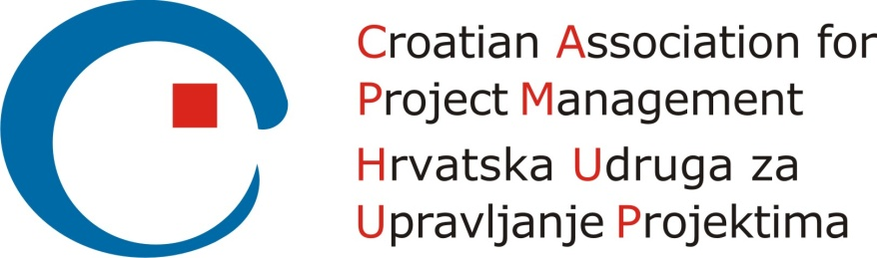

Please consider the environment before printing this document
Version control
Version and date of CVMB approval | Date | Valid until
Version 1.0 | 10.01.2017 | N/A

Configuration control
Date | Version | Section | Change
05.11.2016 | 0.1 | all | - Initial draft
12.12.2016 | 0.2 | all | - Minor changes in wording and style according to Document Design Guidelines
10.01.2017 | 1.0 | all | - Changes made and agreed by CVMB  (Initial / Re-Certification, Reason for appeal, Apeal against Decision or Process, the CB’s outcome)  - Endorsed by CVMB for CB use and modification

Name
Level |  | Domain

Certification and Certification step related to the appeal (mark “X” as appropriate) and date of decision
Certification
Initial Certification
Re-Certification

Certification Step |  | Date
Application
Exam
Project Report
Simulation/Role Based Scenario
Interview
Recertification

Appeal against (mark “X” as appropriate)
Appeal against
Process
Decision

Reason for the Appeal (provide details)

Are there any supporting documents to support your appeal?

Date of appeal (YYYY-MM-DD): __________________________
Signature: ____________________________________________

For the Certification Body office’s use only:
Name who reviewed the appeal |  | Date
Outcome

